

School of Computer Science

Linear and General Regression Models

in Fulfilment of

MATH9903

Maksymilian Drzezdzon

C15311966

Degree: TU060/2

Module Coordinator: Joe Condon

Declaration of Ownership: I declare that the attached work is entirely my own and that all sources have been acknowledged: 🗹

**Date: 04/03/2022**

Introduction

The skin cell data consists of 118 observations of human skin cells colonies. Samples where exposed to solar radiation from 0 (control) to 3.5 minutes in intervals of 0.5 minutes, this experiment was replicated over a ~28 days several times each day per interval of radiation exposure. Albeit some samples were contaminated and had to be discarded. The response variable for this analysis is the number of live cells remaining counted under a microscope after exposure to radiation documented in log2 form. The data are displayed in Table 1 in raw form.

Table 1: Skin Cell Data - first 13 observations

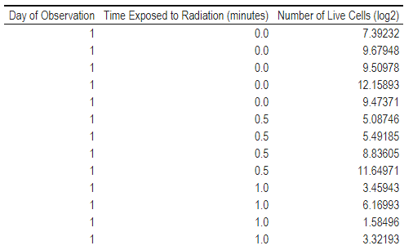

The question at hand is whether there is a statistically significant effect of solar radiation on the mortality of human skin cells. Table 2 presents the mean difference by cell survival count with upper and lower 95% confidence limits based on the student t distribution. There is a downward mean trend that levels off at the 2-minute interval showing an interesting rebound in both mean, lower and upper confidence intervals indicating variable survival rate of cells at longer exposure time. Further supported by Figure 1, group-wise confidence intervals overlap which results in the population mean difference in cell survivorship cannot be assumed statistically different.

TODO review this

Table 2: Cell survival count & 95% CI by time interval

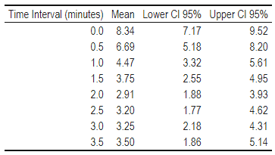

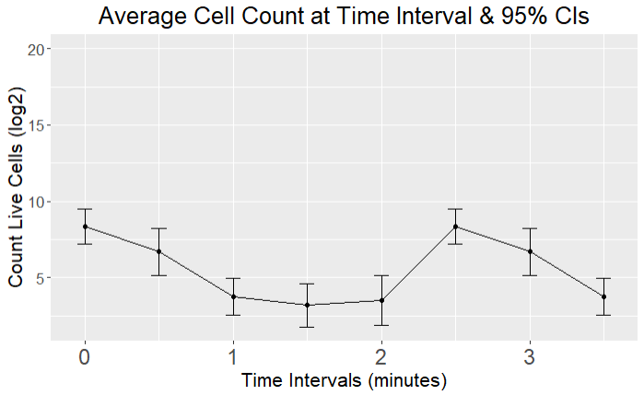

Figure 1: mean difference by cell survival count with upper and lower 95% confidence

Model 1

A linear regression model was fitted to these data with x as the predictor and y and a predictor. To allow maximum flex in the init model an interaction of age and feed was included.

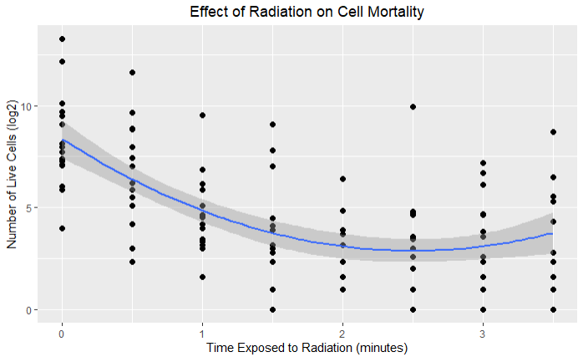

Figure 2: Scatterplot of Cell Survival Count

Model 2

Comparison among x

Code sample

library(pastecs) #For creating descriptive statistic summaries

library(ggplot2) #For creating histograms with more detail than plot

library(psych) # Some useful descriptive functions

library(semTools) #For skewness and kurtosis

library(FSA) # For percentage

library(car) # For Levene's test for homogeneity of variance

library(effectsize) # To calculate effect size for t-test

library(kableExtra) # Used to generate report ready tables

# A copy paste of libraries I use in R projects

# Load data and setup project

setwd("~/GitHub/Masters-Classes-L-O/Applied Statistics/data_stats")

getwd()

data = read.csv("skincells.csv")

anovatab <-

function(mod){

tab=as.matrix(anova(mod))

rows=dim(tab)[1]

moddf=sum(tab[,1])-tab[rows,1]

ssmodel=sum(tab[,2])-tab[rows,2]

msmodel=ssmodel/moddf

f=msmodel/tab[rows,3]

p=1-pf(f,moddf,tab[rows,1])

tab2=tab[(rows-1):rows,]

tab2[1,1:5]=c(moddf,ssmodel,msmodel,f,p)

tab2=rbind(tab2,c(moddf+tab2[2,1],ssmodel+tab2[2,2],rep(NA,3)))

rownames(tab2)=c('Model','Error','Total')

colnames(tab2)[1]='df'

return(print(tab2,na.print = "" , quote = FALSE,digits=3))

}

colnames(data)[1] = "Day of Observation"

colnames(data)[2] = "Time Exposed to Radiation (minutes)"

colnames(data)[3] = "Number of Live Cells (log2)"

tmp_df = data # store reference

data$`Day of Observation` = as.factor(data$`Day of Observation`)

# Plots and table generation

scatter_plot = ggplot(data, aes(x=`Time Exposed to Radiation (minutes)`,

y=`Number of Live Cells (log2)`,

show.legend = T)) +

geom_point(size=2) +

ggtitle("Effect of Radiation on Cell Mortality") +

stat_smooth(method = "lm", formula = y ~ x + I(x^2), size = 1) +

theme(plot.title = element_text(hjust = 0.5))

scatter_plot

data = tmp_df # reset reference

kbl(data) %>%

kable_classic(full_width = F)

group_means=by(data$`Number of Live Cells (log2)`, data$`Time Exposed to Radiation (minutes)`, t.test)

group_means=matrix(c(unlist(group_means[['0']][5:4]),

unlist(group_means[['0.5']][5:4]),

unlist(group_means[['1.0']][5:4]),

unlist(group_means[['1.5']][5:4]),

unlist(group_means[['2.0']][5:4]),

unlist(group_means[['2.5']][5:4]),

unlist(group_means[['3.0']][5:4]),

unlist(group_means[['3.5']][5:4])),

nrow=8, ncol=3, byrow=T)

group_means = data.frame(cbind(group_means,c(0, 0.5, 1.0, 1.5, 2.0, 2.5, 3.0, 3.5)))

group_means$X1 = round(group_means$X1, digit=3)

group_means$X2 = round(group_means$X2, digit=3)

group_means$X3 = round(group_means$X3, digit=3)

colnames(group_means)=c('Mean','Lower CL 95%','Upper CL 95%','Time Interval (minutes)')

ggplot(group_means, aes(x=`Time Interval (minutes)`, y=group_means[,1])) +

geom_errorbar(aes(ymin=`Lower CL 95%`, ymax=`Upper CL 95%`), width=.1) +

geom_line() +

geom_point() +

expand_limits(y=c(5, 20)) +

ylab("Count Live Cells (log2)") +

xlab('Time Intervals (minutes)') +

labs(title="Average Cell Count at Time Interval & 95% CIs") +

theme(text = element_text(size=16), axis.text.x=element_text(size=18), plot.title = element_text(hjust = 0.5))

group_means = group_means %>% relocate(`Time Interval (minutes)`, .before = `Mean`)

kbl(group_means) %>%

kable_classic(full_width = F)